EXPERIMENT :6 ( A ) Simulation and Performance Evaluation of People–Process–Data–Things IoE Framework using Edge/Fog-to-Cloud Pipeline with MQTT and Node-RED

Objective :
To simulate an IoE framework using the People–Process–Data–Things model and evaluate data communication between edge/fog and cloud layers using MQTT and Node-RED.

Procedure :
- Install and launch Node-RED and the Mosquitto MQTT broker.
- Create simulated IoE sensor data representing connected devices.
- Configure MQTT nodes to publish and subscribe to sensor messages.
- Implement edge/fog processing in Node-RED to filter data and detect abnormal values.
- Forward processed data to the cloud layer for monitoring and visualization.
- Observe message flow, latency, and anomaly detection results.
Output :
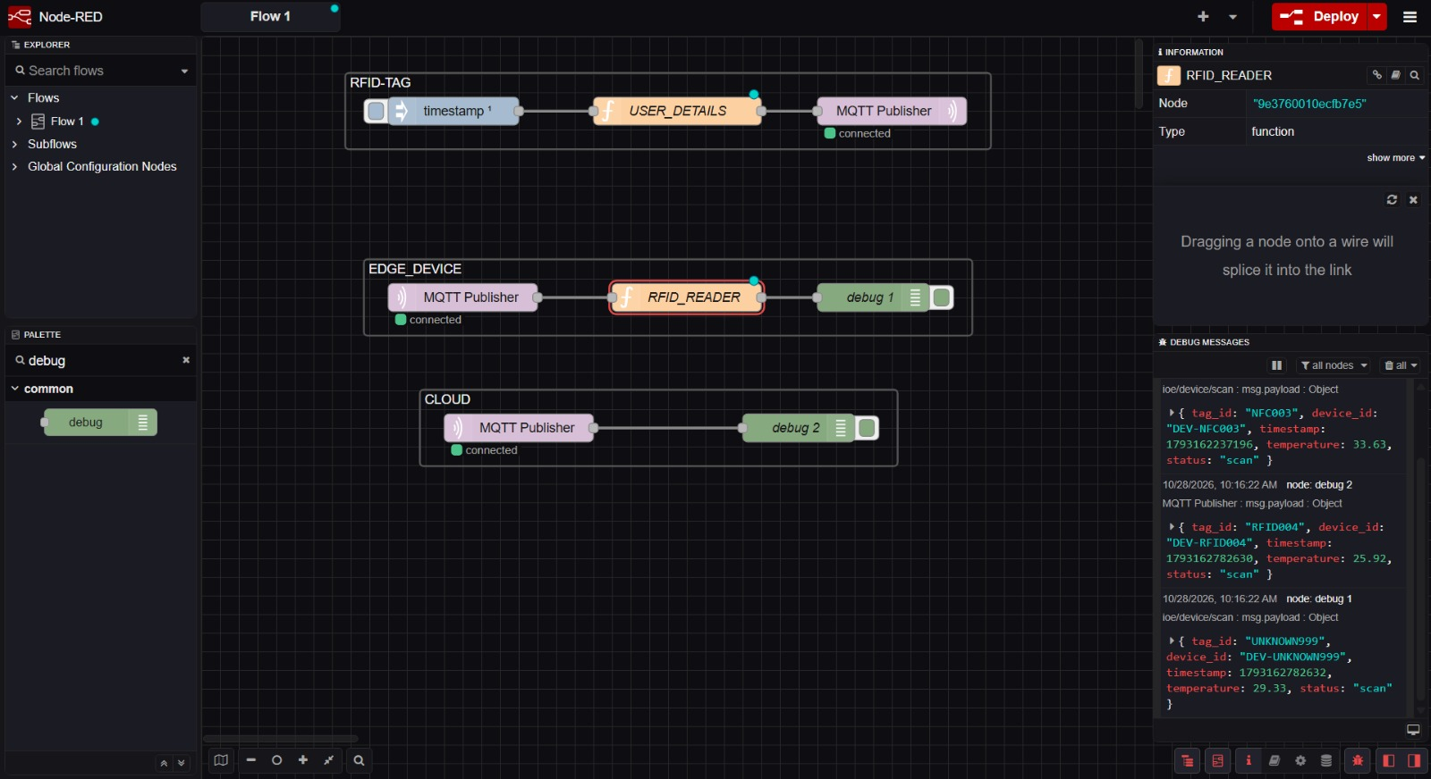
Result :
The IoE framework was simulated successfully using MQTT and Node-RED, demonstrating data flow between edge/fog and cloud layers, sensor data processing, and real-time monitoring.

